**10.Arduino UNO platform-------color_recognition**

1. **Preparation**

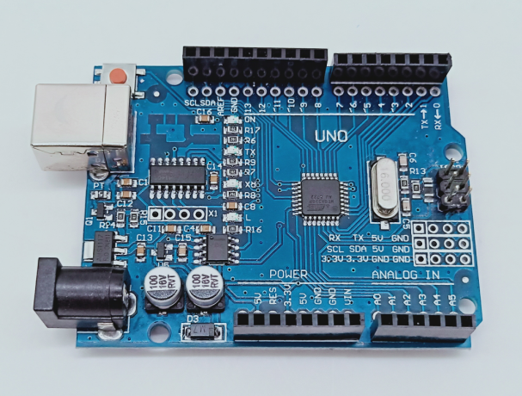

1-1 Arduino UNO board

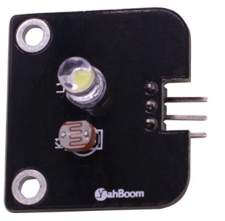

1-2 color_recognition module

**2)Purpose of Experimental**

After the code upload is completed. The color recognition module under the car is turned on automatically, and then the serial monitor of the Arduino IDE is opened to see that the photoresistor reads the illuminance value corresponding to the different colors.

**3)Principle of experimental**

The sensor emits white visible light. Reflected by the reflective surface, the photoresistor can sense the reflected intensity to output different voltages. Through the processing of the voltage signal, the gradation change of the reflecting surface can be analyzed.

**4)Experimental Steps**

4-1 About the schematic

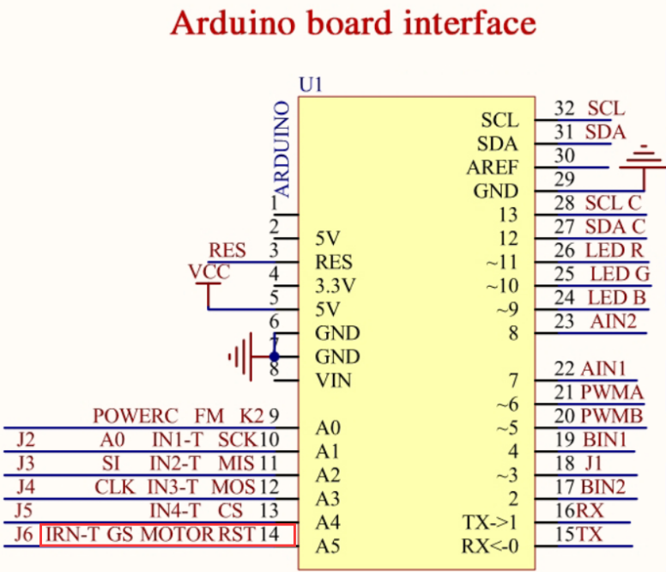

4-1 Arduino UNO interface circuit diagram

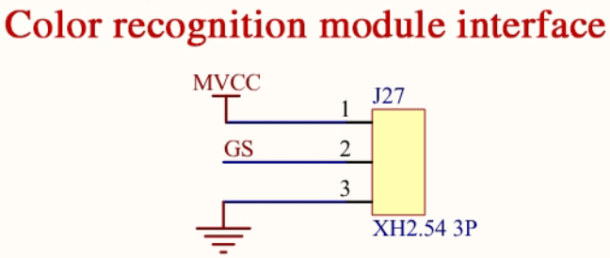

4-2 Color recognition module interface

4-2 According to the circuit schematic:

GS-----A5(Arduino UNO)

4-3 About the code

1. We need to open the code of this experiment:**color_recognition.ino**, click“**√**” under the menu bar to compile the code, and wait for the word "**Done compiling** " in the lower right corner, as shown in the figure below.

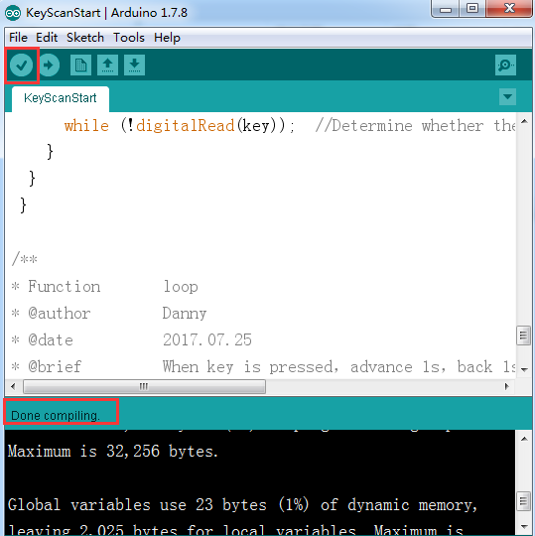

2.In the menu bar of Arduino IDE, we need to select 【Tools】---【Port】--- selecting the port that the serial number displayed by the device manager just now, as shown in the figure below.

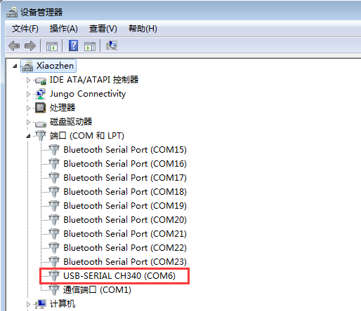

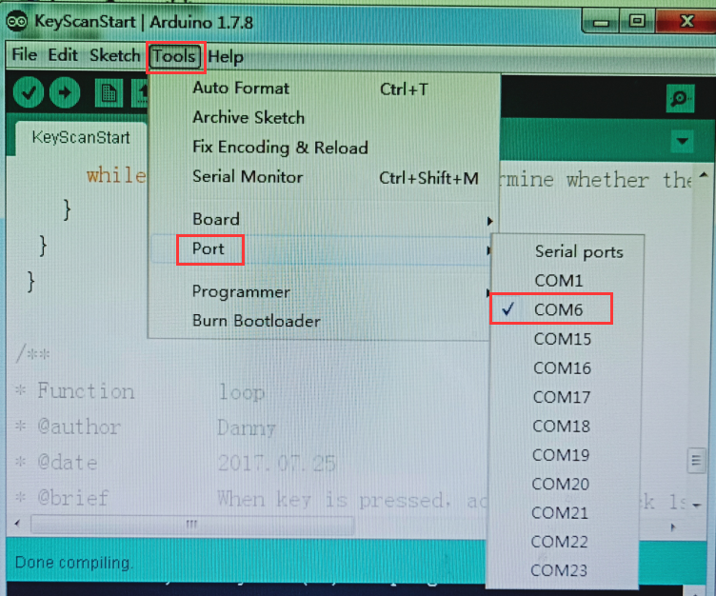

3.After the selection is completed, you need to click “**→**”under the menu bar to upload the code to the Arduino UNO board. When the word “**Done uploading**” appears in the lower left corner, the code has been successfully uploaded to the Arduino UNO board, as shown in the figure below.

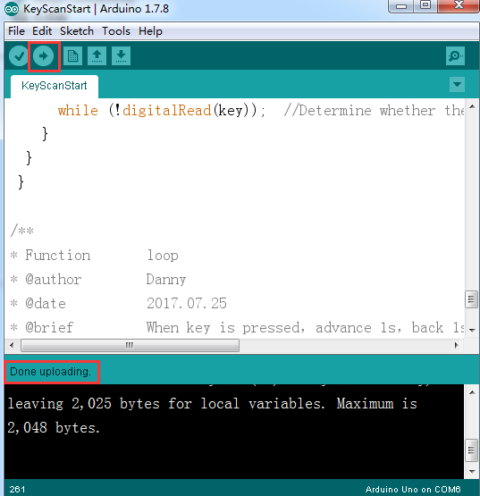

The following is the different data read by the serial port by testing 4 different colors. (The data measured this time is for reference only, the actual test environment shall prevail)

